B.Tech (Artificial Intelligence and Data Science)

MARKET BASKET INSIGNTS

Submitted By

Names of Student
AGILAN.M
BALAMURUGAN.P
ELUMALAI.K
INFANT SURYA.B
KARTHIK.M

DEPARTMENT OF ARTIFICIAL INTELLIGENCE AND DATA SCIENCCE

26/SEPTEMBER/2023

Abstract:
Market Basket Analysis is an important aspect of a retail organization's analytical framework for deciding where products should be placed and developing sales promotions for various segments of consumers to increase customer loyalty and, as a result, benefit. The market is the well-known activity of ARM ultimately used for business intelligent decisions. Market Basket Analysis is a data mining technique that can be used in various fields, such as marketing, bioinformatics, education field, nuclear science, etc. Our objective here is that traders can further improve their business. At the same time, they can make more profits and invest more and more. This will be of great benefit. If the business of traders increases, many people will get employment, as well as customers, will be able to make their way of life easier by getting familiar with different things. Here is a discussion on their methods so that traders in Bangladesh can make proper investments in the right place. The frequent itemsets are mined from the database using the Apriori algorithm and then the association rules are generated. The project will assist supermarket managers in determining the relationship between the items that their customers purchase.

Algorithms Used in Market Basket Analysis
There are multiple data mining techniques and algorithms used in Market Basket Analysis. One of the important objectives is “to predict the probability of items that are being bought together by customers.”

- Apriori Algorithm
- AIS
- SETM Algorithm
- FP Growth

1. Apriori Algorithm
Apriori Algorithm is a widely-used and well-known Association Rule algorithm and is a popular algorithm used in market basket analysis. It is also considered accurate and overtop AIS and SETM algorithms. It helps to find frequent itemsets in transactions and identifies association rules between these items. The limitation of the Apriori Algorithm is frequent itemset generation. It needs to scan the database many times, leading to increased time and reduced performance as a computationally costly step because of a large dataset. It uses the concepts of Confidence and Support.

2. AIS Algorithm
The AIS algorithm creates multiple passes on the entire database or transactional data. During every pass, it scans all transactions. As you can see, in the first pass, it counts the support of separate items and determines then which of them are frequent in the database. Huge itemsets of every pass are enlarged to generate candidate itemsets. After each scanning of a transaction, the common itemsets between the itemsets of the previous pass and the items of this transaction are determined. This algorithm was the first published algorithm which is developed to generate all large itemsets in a transactional database. It focused on the enhancement of databases with the necessary performance to process decision support. This technique is bounded to only one item in the consequent.
- Advantage: The AIS algorithm was used to find whether there was an association between items or not.

- Disadvantage: The main disadvantage of the AIS algorithm is that it generates too many candidates set that turn out to be small. As well as the data structure is to be maintained.

3. SETM Algorithm
This Algorithm is quite similar to the AIS algorithm. The SETM algorithm creates collective passes over the database. As you can see, in the first pass, it counts the support of single items and then determines which of them are frequent in the database. Then, it also generates the candidate itemsets by enlarging large itemsets of the previous pass. In addition to this, the SETM algorithm recalls the TIDs(transaction ids) of the generating transactions with the candidate itemsets.
- Advantage: While generating candidate itemsets, the SETM algorithm arranges candidate itemsets together with the TID(transaction Id) in a sequential manner.

- Disadvantage: For every item set, there is an association with Tid; hence it requires more space to store a huge number of TIDs.

4. FP Growth
FP Growth is known as Frequent Pattern Growth Algorithm. FP growth algorithm is a concept of representing the data in the form of an FP tree or Frequent Pattern. Hence FP Growth is a method of Mining Frequent Itemsets. This algorithm is an advancement to the Apriori Algorithm. There is no need for candidate generation to generate a frequent pattern. This frequent pattern tree structure maintains the association between the itemsets.
A Frequent Pattern Tree is a tree structure that is made with the earlier itemsets of the data. The main purpose of the FP tree is to mine the most frequent patterns. Every node of the FP tree represents an item of that itemset. The root node represents the null value, whereas the lower nodes represent the itemsets of the data. The association of these nodes with the lower nodes, that is, between itemsets, is maintained while creating the tree.

In this project, I will be implementing Market Basket Analysis, a data mining technique used to identify associations and patterns in customers' purchasing behavior. By analyzing transactional data, we aim to uncover relationships between products frequently bought together, which can provide valuable insights for businesses, such as cross-selling opportunities, optimizing product placement, and improving marketing strategies.
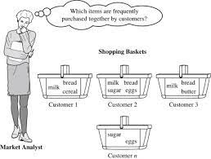
PROGRAME

import pandas as pd
import numpy as np
import matplotlib.pyplot as plt
import seaborn as sns

df = pd.read_csv("Groceries_dataset[1].csv")
df.shape
df.describe()
df.info()
df.notnull().sum()
df.isna().sum()
df.head()
df.set_index('Date',inplace = True)
df.head()
df.index=pd.to_datetime(df.index)
df.head()
df.shape
total_item = len(df)
total_days = len(np.unique(df.index.date))
total_months = len(np.unique(df.index.year))
print(total_item,total_days,total_months)

plt.figure(figsize=(15,5))
sns.barplot(x = df.itemDescription.value_counts().head(20).index, y = df.itemDescription.value_counts().head(20).values, palette = 'gnuplot')
plt.xlabel('itemDescription', size = 15)
plt.xticks(rotation=45)
plt.ylabel('Count of Items', size = 15)
plt.title('Top 20 Items purchased by customers', color = 'green', size = 20)
plt.show()

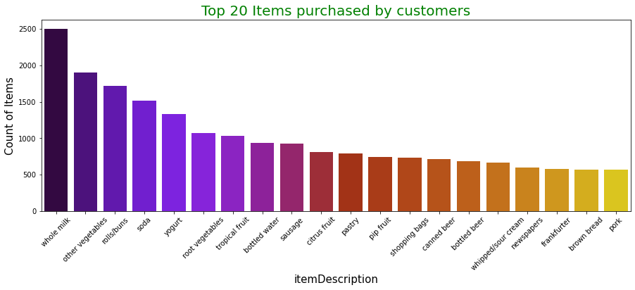

df['itemDescription'].value_counts()
df=df.groupby(['Member_number','Date'])['itemDescription'].apply(lambda x: list(x))
df.head(10)
transactions = df.values.tolist()
transactions[:10]

from apyori import apriori
rules = apriori(transactions, min_support=0.00030,min_confidence = 0.05,min_lift = 2,min_length = 2)
results = list(rules)
results

def inspect(results):
lhs = [tuple(result[2][0][0])[0] for result in results]
rhs = [tuple(result[2][0][1])[0] for result in results]
supports = [result[1] for result in results]
confidences = [result[2][0][2] for result in results]
lifts = [result[2][0][3] for result in results]
return list(zip(lhs, rhs, supports, confidences, lifts))
ordered_results = pd.DataFrame(inspect(results), columns = ['Left Hand Side', 'Right Hand Side', 'Support', 'Confidence', 'Lift'])

ordered_results

OUTPUT

Left Hand Side | Right Hand Side | Support | Confidence | Lift
0 | artif. sweetener | soda | 0.000468 | 0.241379 | 2.485725
1 | condensed milk | berries | 0.000334 | 0.051020 | 2.341774
2 | brandy | whole milk | 0.000869 | 0.342105 | 2.166281
3 | sweet spreads | butter | 0.000334 | 0.073529 | 2.087705
4 | liver loaf | canned beer | 0.000401 | 0.120000 | 2.557778
... | ... | ... | ... | ... | ...
99 | rolls/buns | yogurt | 0.000601 | 0.204545 | 2.381800
100 | shopping bags | yogurt | 0.000401 | 0.206897 | 2.409178
101 | whole milk | sausage | 0.001470 | 0.131737 | 2.182917
102 | pastry | whole milk | 0.000334 | 0.090909 | 7.817659
103 | rolls/buns | whole milk | 0.000334 | 0.062500 | 5.599925
104 rows × 5 columns

Conclusion
In this tutorial, we discussed Market Basket Analysis and learned the steps to implement it from scratch using Python. We then implemented Market Basket Analysis using Apriori Algorithm. We also looked into the various uses and advantages of this algorithm and learned that we could also use FP Growth and AIS algorithms to implement Market Basket Analysis.

